Case 5-Asia-China-Bronze-Elephant-Shang
SHAPE \* MERGEFORMAT 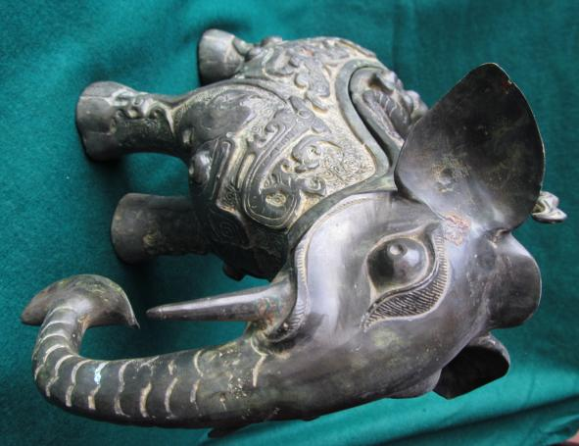
Fig. 1
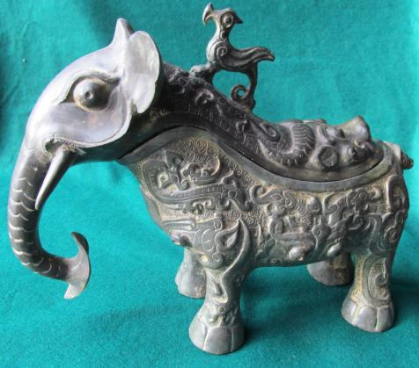
Fig. 2
SHAPE \* MERGEFORMAT 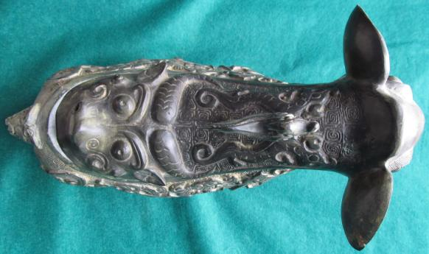
Fig. 3
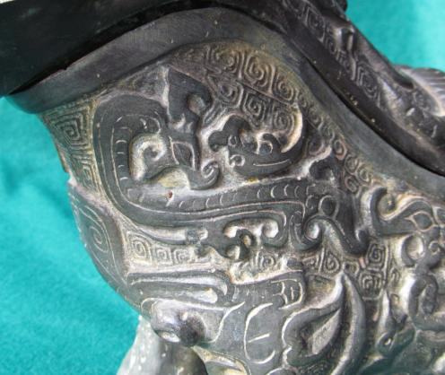
Fig. 4
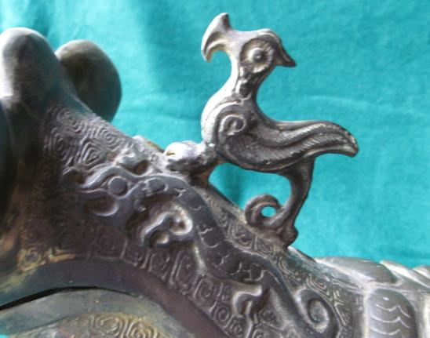
Fig. 5
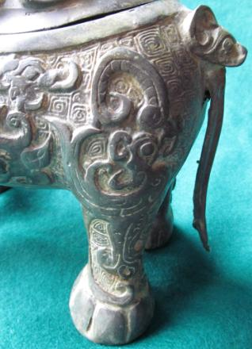
Fig. 6
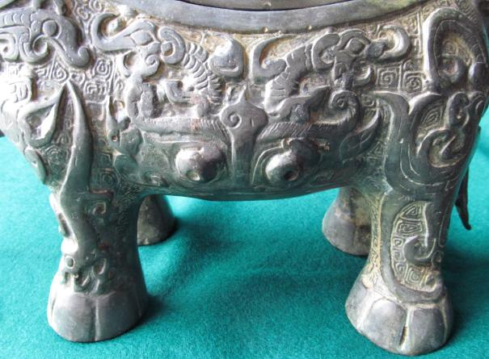
Figs 1-7. Asia-China-Bronze-Elephant-Shang
Case No.: 5
Accession Number:
Formal Label: Asia-China-Bronze-Elephant-Shang
Display Description:
Based on the image of an elephant, as can be seen from the trunk and protruding eyes at its front, this rare example of a ritual vessel known as a guang (觥 )( kung¹, Wade-Giles, hereinafter abbreviated "w-g"; gōng, Pinyin, hereinafter abbreviated "p") was used to pour wine or other potent beverages from the spout of the vessel which is in the form of the head of the creature whose mouth constitutes the end of the spout. Guang were used in ceremonies linking the rulers of the Shang dynasty (ca. 1600-1050 BCE) with their ancestors and supernatural forces. The metaphoric imagery that defines this vessel typifies bronzes cast at the late Shang (ca. 1300-1050 BCE) at the capital of Anyang, Henan Province, in north-central China.
The first radical of guang "角" refers to an ancient drinking vessel made from the horn of an animal that is obvious in its oracle-bone script radical of a pointed horn. In Indo-European languages this ancient vessel type was called a rhyton, ῥυτόν in ancient Greek, which is from Greek rhein, "to flow" (Liddell and Scott 1940) which is from the proto-Indo-European*sreu-, "flow" (Pokorny 1959: 1003), which is the root of rhutos, "stream," and in its neuter form, rhuton, which is the vessel used to pour. The combination of a vessel connected with the act of flowing fluid and an animal's head as its vehicle may have ancient connections with the Chinese Shang guang, because the spout of the guang is in the form of the head of the creature whose mouth constitutes the end of the spout which is associated with flowing fluid. Furthermore, the horned water-buffalo-like creature on the rump of the elephant suggests a connection with the ancient oracle -bone script radical as a pointed horn
LC Classification:
Date or Time Horizon: early Anyang period (ca. 1300-1050 BCE)
Geographical Area:
Map:
GPS Coordinates:
Cultural Affiliation:
Medium:
Dimensions: L 14.7 in. (37.4 cm), H 9.5 in. (24.1 in)
Weight:
Provenance:
Condition: original
Discussion:
References:


Fig. 1. Horned creature, see Fig. 8.
In addition, the creatures on both the second millennium rhyta and the guang are fantastic. In Persia they are often griffins or other imaginary creatures. In Shang China the creatures portrayed suggest a correspondence with the fantastic animals of the Shan Hai Jing (山海經) or "Classic of the Mountains and Seas," a 4th century BCE folkloric, geographical, natural historical and mythological collection based on ancient records no longer extant (see Anon. in "References" below). The Shan Hai Jing provides a sourcebook of the Chinese predilection for the fantastic, whether it be animals or geographical oddities as they are related to the belief in the principle of Shang Ti (上帝) or "Celestial Ruler" of the universe. Shang Ti (w-g) (Shang Di, p) as cited in the Shang period oracle bone inscriptions, presided over a hierarchy of lesser deities of which these guang vessels may represent as their earthly images. Since guang vessels were used to dispense psychoactive substances in ceremonial settings, it is possible that they represented the vehicles that commuted Shang Ti's visions of the celestial world in both its mythical and moral dimensions to His believers.
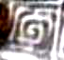
Fig. 2. Thundercloud motifs (leiwen), see. Fig. 11
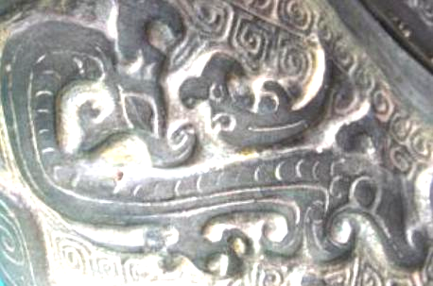
Fig. 3. Dragon motif on throat, see Fig. 7
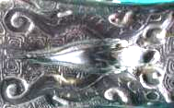
Fig. 4. Dragon motifs on lid, see Fig. 8
The idea of these guang as visions of the celestial world is reinforced by the low-relief background of linked spirals known as thundercloud motifs (leiwen) as seen in the figures below. Dragons are strategically placed both on the throat of the vessel, the body of the vessel and the vessel's lid, thereby encompassing both parts of the vessel. The dragon in Shang times was associated with rain and the Yang principle, and those with five claws as shown in Fig. 4 were considered to be Imperial creatures and associated with immortality. This suggests that the imagery of the dragons was a medium by which immortality or the vision of such) was commuted to those participating in the libations. Fig. 11 shows two rampant dragons that form the upper part of a beautifully stylized a taotie (monster mask) frieze on the body of the vessel with two protruding eyes below.
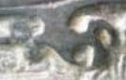
Fig. 5. Dragon with 5 claws, see Fig. 9.
The Chinese were one of the first cultures to develop sophisticated bronze casting technology, and they did it in a unique way. This guang was cast using several ceramic piece-molds, a method that has no ancient parallel: ceramic molds carved with complicated multilayered designs were assembled around an interior clay core and then hardened. Molten bronze (with varying percentages of tin added to copper) was poured into the cavity between the core and the mold. Once the bronze had cooled and hardened, the exterior ceramic molds were broken to reveal the vessel. Several components were essential to the successful production of bronze vessels in this manner: the availability of mined and processed metals, skilled clay sculptors, and knowledgeable metallurgists.
The late Shang (ca. 1300-1050 BCE) time horizon coincides with the Indo-European invasions of the sub-the Peoples' Republic of China, but was previously known as Sinkiang and was infiltrated from the east during the second millennium BCE by Uyghurs (Turkic Mongolians from Mongolia) who became, after the death of Siddhartha Gautama, Buddhists, and they built and carved out of the available limestone many grottoes which they lavishly decorated. During this period of ca. 1300-1200 BCE influxes of Indo-Europeans from the area adjacent to the Black and Caspian Seas also penetrated Sinkiang from the west. The result was an admixture of Mongolians and Indo-Europeans. The Indo-Europeans are embalmed in the mummies of Cherchen, which lies easterly on the southern Silk Road route of the Tarim Basin. The Uyghurs are interspersed throughout the oasis towns both north and south of the Tarim Basin. The source of the advent of bronze in China is contested, but it is known that the Indo-Europeans had knowledge of the craft of bronze metallurgy and may have been the stimulus for the Shang Bronze Age. Therefore, these guang vessels may represent not only the expression of Shang Chinese iconography but also the utilization of Indo-European bronze metallurgy. The implications are reversionary. What if the Chinese Han had not discovered the art and technology of bronze metallurgy of which they had so long prized themselves and that it had been an imported technology of the Indo-Europeans?

References:
Anon. [4th cent BCE]. Shan Hai Jing. (山海經) or "Classic of the Mountains and Seas." There is one translation by Ann Birrell into English (Birrell, Anne. 2000. The Classic of Mountains and Seas. London: Penguin) which is meant for a popular audience but is unusable for scholarly purposes since it lacks Chinese transliterations of names, which Birrell has so fancifully translated that reverse translations are impossible. An exposition of the bestiary portion has been produced by Richard E. Strassberg with illustrations (Strassberg, Richard. 2002. A Chinese Bestiary: Strange Creatures from the Guideways Through Mountains and Seas. Los Angeles: University of California Press). Rémi Mathieu's French translation is the best available in a critical edition with an accompanying glossary and index. This unfortunately was produced in a limited 2 v. edition (Etude sur la mythologie et l'ethnologie de la Chine ancienne [Paris] : Collège de France, Institut des hautes études chinoises, Diffusion De Boccard, 1983. Mémoires de l'Institut des hautes études chinoises, v. 22). A massive, three volume Chinese edition is the best for its completeness of text. (Yang, Shoujing, 1839-1915, ed. 1989. Shan Hai Jing (山海經). Shui jing zhu shu. [Nanjing] : Jiangsu gu ji chu ban she,. 3 v.: [45], 3508, 62 p.)
Liddell, Henry George; Scott, Robert. 1940. "ῤυτὀν". A Greek-English Lexicon. Revised and augmented throughout by Sir Henry Stuart Jones with the assistance of Roderick McKenzie. Oxford: Clarendon Press.
Pokorny, Julius. 1959. "sreu". Indogermanisches etymologisches Wörterbuch. Bern: Francke.

